Project Planning Phase

**Product Backlog, Sprint Planning, Stories, Story points**

|  |  |
| --- | --- |
| Date | 22 October 2022 |
| Team ID | PNT2022PMID25179 |
| Project Name | Smart Fashion Recommender Application |
| Maximum Marks | 8Marks |

Product Backlog, Sprint Schedule

|  |  |  |  |  |  |  |
| --- | --- | --- | --- | --- | --- | --- |
| Sprit | Functional Requirement  (Epic) | User Story Number | User Story/Task | Story Points | Priority | Team Members |
| Sprint-1 | Admin Panel | USN-1 | As a Admin,   * Can login * Products-CRUD * User List * Orders List | 20 | High | S Angeline Rebecca  T Harini  R R Sanjunaa  R Vishnu Priya |
| Sprint-2 | User Panel | USN-2 | As a user,   * Register, Login, Email Verification * Manual Search * Order placement, Order Details | 20 | High | S Angeline Rebecca  T Harini  R R Sanjunaa  R Vishnu Priya |
| Sprint-3 | Chat Bot | USN-3 | * Automatic product search base does user information * Can make order without any manual process | 20 | High | S Angeline Rebecca  T Harini  R R Sanjunaa  R Vishnu Priya |
| Sprint-4 | Testing & Deploy | USN-4 | * Unit Testing * Containerize the app * Deployment in IBM CLOUD | 20 | High | S Angeline Rebecca  T Harini  R R Sanjunaa  R Vishnu Priya |

**Project Tracker, Velocity & Burndown Chart:(4Marks)**

|  |  |  |  |  |  |  |
| --- | --- | --- | --- | --- | --- | --- |
| Sprint | Total Story Points | Duration | Sprint Start Date | Sprint End Date (Planned) | Story Points Completed (as on Planned End Date) | Sprint Release Date (Actual) |
| Sprint-1 | 20 | 6Days | 24Oct2022 | 29Oct2022 |  | 29 Oct2022 |
| Sprint-2 | 20 | 6Days | 31Oct2022 | 05Nov2022 |  | 05 Nov2022 |
| Sprint-3 | 20 | 6Days | 07Nov2022 | 12Nov2022 |  | 12 Nov2022 |
| Sprint-4 | 20 | 6Days | 14Nov2022 | 19Nov2022 |  | 19 Nov2022 |

Velocity:

Imagine we have a 10-day sprint duration, and the velocity of the team is 20 (points per sprint). Let’s calculate the team’ s average velocity(AV) per iteration unit (story points per day)

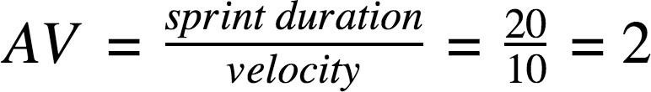

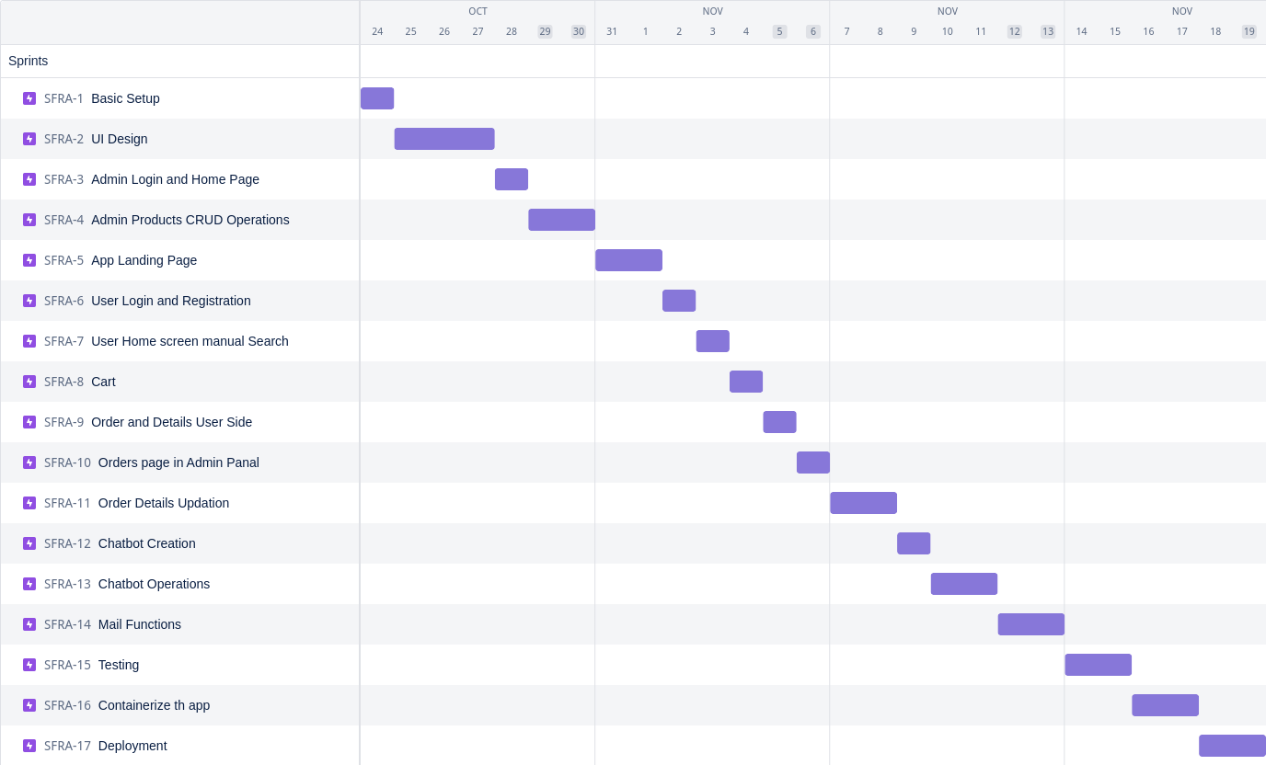Burn down Chart: